Call for Presentations: Deadline for submissions is August 3, 2020

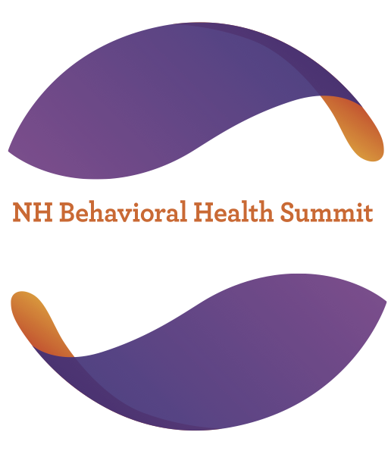

The 2020 NH Behavioral Health Summit

December 7 & 8, 2020

This annual Summit is designed to bring together non-profit leaders, health care providers, clinical and, licensed professionals, and public policy advocates in the mental health and substance use disorder community. The goal is to bring the behavioral health community together where shared public policy goals, professional development and meaningful networking can occur. The NH Behavioral Health Summit is a successful collaboration between The NH Community Behavioral Health Association (CBHA), the NH Alcohol and Other Drug Service Providers Association (NHPA) and the NH Alcohol and Drug Abuse Counselors Association (NHADACA) and focuses on setting the public policy stage for key legislative and agency initiatives as well as integration and building capacity for primary care, mental health and substance use services.

Goal: This event seeks to enhance the health and well-being of people throughout New Hampshire through thoughtful public policy and the integration, and quality provision, of vital community services. The purpose of the NH Behavioral Health Summit is to support integrated substance use, mental health and primary care services.

You are invited to submit workshop proposals to be presented at the virtual 2020 NH Behavioral Health Summit, on December 7 & 8, 2020. We welcome proposals from professionals, advocates, policymakers and volunteers in behavioral health services including primary health care, mental health services and substance use prevention, treatment and recovery services. In effort to advance the integration of systems and service provision throughout New Hampshire, we especially invite workshop proposals from people working in integrated systems.
Conference Objectives:

- Provide opportunities that increase familiarity of the various disciplines and systems in order to promote alignment of services, integration and enhanced care coordination;
- Provide educational opportunities that address the behavioral health policy and service needs of children /adolescents, adults, and other special populations;
- Provide educational opportunities that help participants understand the changing substance use, mental health, and primary health landscape;
- Provide educational opportunities that encourage expansion of the workforce relative to health promotion, prevention, early identification and intervention, treatment and recovery supports;
- Support the provision of evidenced based practices; and
- Provide opportunities for policy makers to interact with service providers, so that this interaction may inform policy needs and address policy barriers to service provision.

Workshop presentations must relate to the conference goal, theme and objectives.

Audience

Conference attendees are drawn from various professions and organizations including, but not limited to:
- policymakers, legislators
- agency administrators, board of directors
- integrated delivery networks
- children’s behavioral health professionals; early childhood professionals
- substance use continuum of care professionals; prevention specialist and community coalitions; treatment providers; and recovery support professionals
- mental health counselors; case managers; peer support specialists
- primary health care; hospital administrators; medical professionals
- health and human service professionals; social service professionals

Presentation Format

The workshop sessions will be virtual and 60 minutes in length.

The conference goal, theme, and objectives described above lend themselves to presentations that focus on, but are not limited to, the following “tracks”:
- Cross-systems alignment and integration
- Organizational Management
- Substance Misuse Prevention
- Cultural considerations/priority populations
- Policy initiatives, needs and barriers

- Children’s behavioral health
- Evidence based practices
- Models for success
- Clinical skill building
- Workforce development

Content Level:
- Core – introductory presentation of the topic
- Intermediate – more detailed presentation of the topic
- Advanced – in-depth and/or practical application presentation of the topic

Review Criteria
Proposals will be reviewed by a committee and selected based on relevance to the conference theme and objectives, timeliness of the topic, and creativity of approach. Workshop description and objectives should be clear and well defined. The selection committee reserves the option to request additional information in support of the workshop proposal.

Submission Guidelines
- Deadline for submission is August 3, 2020
- Proposals should be submitted to:
NH Alcohol & Drug Abuse Counselors Association
130 Pembroke Road, Suite 100, Concord, NH 03301
Email: TrainingInstitute@nhadaca.org
Phone: (603) 225-7060
- Proposals must be complete and will be reviewed when all requested information has been submitted (see workshop proposal application form)
- All presentations will be recorded and made available to all registrants of the conference. Submitting a proposal acknowledges that presenters have given their consent for this recording and posting of the workshop. Recordings of the workshops are the property of the NH Behavioral Health Summit and may be posted online for future viewing as on-demand webinars.
- In lieu of presenter fees/honoraria, conference registration fees will be waived for all presenters. Any guest speaker, or panel moderator, must be identified as a presenter within the initial proposal.
- Presenters will receive a certificate of Continuing Education hours
- Selections will be made by September 6, 2020, with notification to follow shortly after
- All committee decisions are final
Workshop Proposal Application Form
NH Behavioral Health Summit

Presentations must relate to the conference goal, theme, and objectives.

Workshop Title:

Recording Acknowledgement: If selected for the NH Behavioral Health Summit, each of the presenters identified in this proposal acknowledge and provide consent for the recording and posting of this workshop. Each of the presenters identified in this proposal is aware that all workshop and keynote presentations will be recorded and made available to all registrants of the conference. Each of the presenters identified in this proposal is aware that submitting a proposal acknowledges that they have given their consent for this recording and posting of the workshop. I understand and consent that recordings of the workshops are the property of the NH Behavioral Health Summit and may be posted online for future viewing as on-demand webinars.

Content Level: Core Intermediate Advanced

Length of Presentation: 60 Minutes

Instructional Methodology:
Lecture Case Presentation
Break-out Rooms Other (please describe):

Any other presentation needs:
Please describe:

Workshop Description:

Workshop Objectives:

Proposal Narrative (include description of relevance to one or more conference objectives):

Bibliography (title, author and publishing date, for 3 resources cited in the presentation):

Presenter Information Form
NH Behavioral Health Summit

Lead Presenter:
Name:
Title:
Agency:
Street Address:
City/State/Zip:
E-mail:
Phone:
Highest Education Degree: Year completed:
Brief Bio (2-4 sentences describing presenter’s expertise/experience to teach this topic):

Co-Presenter (if more than one co-presenter, please provide information on separate sheet):
Name:
Title:
Agency:
Street Address:
City/State/Zip:
E-mail:
Phone:
Highest Education Degree: Year completed:
Brief Bio (2-4 sentences describing co- presenter’s expertise/experience to teach this topic):

Co-Presenter (if more than one co-presenter, please provide information on separate sheet):
Name:
Title:
Agency:
Street Address:
City/State/Zip:
E-mail:
Phone:
Highest Education Degree: Year completed:
Brief Bio (2-4 sentences describing co- presenter’s expertise/experience to teach this topic):

Contact person if different from Lead Presenter:
Name:
Title:
Agency:
Street Address:
City/State/Zip:
E-mail:
Phone:
PLEASE ATTACH RESUMES FOR EACH PRESENTER
Call for Presentations – Submission Check List
NH Behavioral Health Summit

Have you?

Completed all fields on the Workshop Proposal Application Form?

Completed all fields on the Presenter Information form?

Attached resumes for each presenter?

Checked the acknowledgement/consent box for recording of presentations?

Call for Presentations: Deadline for submissions is August 3, 2020

For more information contact:
Alyssa Demers
NH Alcohol & Drug Abuse Counselors Association
603-225-7060
TrainingInstitute@nhadaca.org

Thank you!

